**Apache installation and SSL Configuration on linux**

Use below command to install apache on REL

yum -y install httpd

We can use below command to check if httpd is installed or not?

rpm -qa | grep httpd

Now we need to add a VirtualHost So follow the below steps to do the same.

Before any changes in Apache main Configuration file (httpd.conf) take a backup by below command

cd /etc/httpd/conf

cp httpd.conf httpd.conf.backup

Now edit the httpd.conf file and go to the end of the configuration file, follow the below steps

nano /etc/httpd/conf/httpd.conf

Now add the below lines to add a VirtualHost

Namevirtualhost 192.168.0.107:80

<virtualhost 192.168.0.102:80?

Serveradmin [webmaster@linuxbook.com](mailto:webmaster@linuxbook.com)

Documentroot /var/www/html/elinuxbook.com

Servername [www.elinuxbook.com](http://www.elinuxbook.com)

Errorlog logs/ww.elinuxbook.com-error-log

Customlog logs/www/elinuxbook.com-access-log

</virtualhost>

192.168.0.107 is the ip address

As we can see above on VirtualHost we have mentioned **DocumentRoot** Path i.e. **/var/www/html/elinuxbook.com**, So we need to create a Directory **elinuxbook.com** and copy our Website Document’s on this path.

For now we can create a sample index.html file as a Website Document  and put some text like **Welcome to ELinuxBook** (As per my Scenario) by edit it, so follow the below steps :

# mkdir /var/www/html/elinuxbook.com

# nano /var/www/html/elinuxbook.com/index.html

# ls -l /var/www/html/elinuxbook.com/

total 4

-rw-r--r-- 1 root root 22 Dec 11 20:21 index.html

Now check the httpd.conf if everything is perfectly configured by below command

Check apache config correct r not

Httpd –t

Syntax ok

As we can see above everything looks good, So let’s start the apache server and also start it on Startup by below command.

# /etc/init.d/httpd start

Starting httpd: [ OK ]

# chkconfig --level 35 httpd on

# chkconfig --list httpd

httpd 0:off 1:off 2:off 3:on 4:off 5:on 6:off

 If you want to access by domain name as mentioned in VirtualHost i.e. **www.elinuxbook.com**, you have to Configure [BIND DNS Server](http://www.elinuxbook.com/how-to-setup-primary-dns-server-with-bind-in-linux/) OR just enter in **/etc/hosts** file as shown below.

Just edit the /etc/hosts file using command **nano /etc/hosts**  and enter the line as highlighted below on the snapshot.

<http://www.elinuxbook.com/wp-content/uploads/2016/12/SSL-CONFIGURATION-IN-APACHE-WEB-SERVER-3.png>

**“As we can see above now our site is opening as http://localhost means now it’s not configured with SSL, Let’s configure this VirtualHost to work over https, So Follow the below steps”**

**Steps to install required ssl.**

We need to install two Packages to Configure SSL for Apache VirtualHost i.e.

1. **openssl**  
2. **mod_ssl**

So Let’s Install required packages by below command.

yum -y install openssl mod_ssl

step 2:

generate self singed certificate:

Now Let’ go ahead and Generate Self-Signed Certificate for our VirtualHost to be work as SSL, So Follow the below Steps :

Generate Private Key using below Command :

openssl genrsa -out elinuxbook.key 2048

Generating RSA private key, 2048 bit long modulus

............+++

.........................................+++

e is 65537 (0x10001)

**Generate CSR i.e. Certificate Signing Request :**

# openssl req -new -key elinuxbook.key -out elinuxbook.csr

You are about to be asked to enter information that will be incorporated

into your certificate request.

What you are about to enter is what is called a Distinguished Name or a DN.

There are quite a few fields but you can leave some blank

For some fields there will be a default value,

If you enter '.', the field will be left blank.

-----

Country Name (2 letter code) [GB]:IN

State or Province Name (full name) [Berkshire]:Maharashtra

Locality Name (eg, city) [Newbury]:Mumbai

Organization Name (eg, company) [My Company Ltd]:ELinuxBook

Organizational Unit Name (eg, section) []:Linux Education

Common Name (eg, your name or your server's hostname) []:elinuxbook.com

Email Address []:admin@elinuxbook.com

Please enter the following 'extra' attributes

to be sent with your certificate request

A challenge password []:

An optional company name []:

[root@localhost ~]#

**Generate Self-Signed Certificate :**

# openssl x509 -req -days 1095 -in elinuxbook.csr -signkey elinuxbook.key -out elinuxbook.crt

Signature ok

subject=/C=IN/ST=Maharashtra/L=Mumbai/O=ELinuxBook/OU=Linux Education/CN=elinuxbook.com/emailAddress=admin@elinuxbook.com

Getting Private key

So we Generated all required Certificates as shown below

ls

anaconda-ks.cfg Desktop **elinuxbook.crt** **elinuxbook.csr** **elinuxbook.key** install.log install.log.syslog

**Step : 3 Copy Certificates to Necessary Location**

* Now we have to copy all created Certificates to necessary location.
* **Copy the elinuxbook.crt to /etc/pki/tls/cert**

cp elinuxbook.crt /etc/pki/tls/certs/

# ls /etc/pki/tls/certs/

ca-bundle.crt elinuxbook.crt localhost.crt make-dummy-cert Makefile

* **Copy the elinuxbook.key to /etc/pki/tls/private**
* cp elinuxbook.key /etc/pki/tls/private/
* # ls
* anaconda-ks.cfg Desktop elinuxbook.crt elinuxbook.csr elinuxbook.key install.log install.log.syslog
* **Copy the elinuxbook.csr to /etc/pki/tls/private**

# cp elinuxbook.csr /etc/pki/tls/private/

# ls /etc/pki/tls/private/

elinuxbook.csr elinuxbook.key localhost.key

### Step : 4 Configure ssl.conf

As we can see above we copied all Certificates to required directories, now let’s configure the **ssl.conf** file  as shown below.

Edit the /etc/httpd/conf.d/ssl.conf file as shown below

# nano /etc/httpd/conf.d/ssl.conf

* now search for **SSLCertificateFile** and then mention the path of SSL Certificate file infront of that which we created above i.e. **elinuxbook.crt**
* After mention the path the line should look like as mentioned below :
* **SSLCertificateFile /etc/pki/tls/certs/elinuxbook.crt**
* now search for **SSLCertificateKeyFile** and then mention the path of SSL Certificate Key file infront of that which we created above i.e. **elinuxbook.key**
* After mention the path the line should look like as mentioned below :
* **SSLCertificateKeyFile /etc/pki/tls/private/elinuxbook.key**

<http://www.elinuxbook.com/wp-content/uploads/2016/12/SSL-CONFIGURATION-IN-APACHE-WEB-SERVER-4.png>

* As shown on the snapshot above required changes in **ssl.conf** configuration file hilighted by blue color.

### Step : 5  SSL Configuration for VirtualHost

* Now we have to make changes in our VirtualHost as shown below :
* Before we have added VirtualHost for Port 80 on this tutorial above, now we need to make changes in that configuration To Work for https, So Follow the below steps.

**VirtualHost Configured for Port 80 as shown below :**

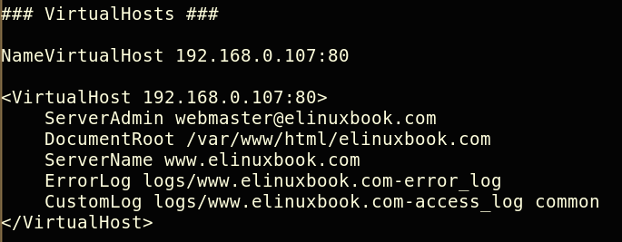

* We need to do changes on above configuration for **https** is :
* Replace the Port **80** with **443** as Port Number of SSL is **443**  and then place below mentioned lines after **<VirtualHost 192.168.0.107:443>**  
   **# To Enable the SSL Support for this VirtualHost**  
  SSLEngine on  
   **# Path of SSL Certificate File**  
  SSLCertificateFile /etc/pki/tls/certs/elinuxbook.crt  
   **# Path of SSL Certificate Key File**  
  SSLCertificateKeyFile /etc/pki/tls/private/elinuxbook.key  
  After Complete changes the VirtualHost should look like as shown on the snapshot below, and all changes are hilighted by blue color.

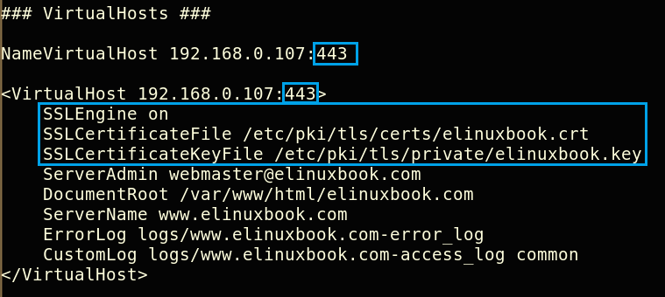

*VirtualHost after SSL configuration*

Now restart the Apache Service by below command.

# /etc/init.d/httpd restart

Stopping httpd: [ OK ]

Starting httpd: [ OK ]

* So We have completed our configuration part, Now it’s time for Testing So Just open Web Browser and Enter **https://<IP_Address_Of_The_Apache_Web_Server>**, In our Case It’s **https://192.168.0.107** as shown in the snapshot below.

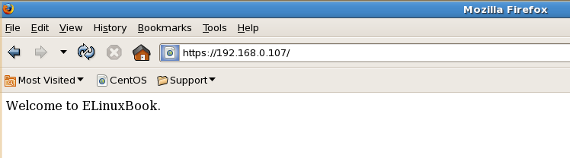

*Testing Webpage with https*

**Note :**In Firefox Web Browser you may found Exception Error, So just Click on add Exception and Accept the Certificate manually. Then you can access https Site on Firefox. Follow the same step for Google Chrome also.

So This is how we can do SSL Configuration in Apache Web Server, If you found this article Useful then Like It, Share It or Subscribe us For Updated Guides and Tutorials.

If you have some thing to say then feel free to Comment on the Comment box below.

Refference link please follow the link

http://www.elinuxbook.com/step-by-step-ssl-configuration-in-apache-web-server/

[+1**4**](https://plus.google.com/share?url=http%3A%2F%2Fwww.elinuxbook.com%2Fstep-by-step-ssl-configuration-in-apache-web-server%2F)

[Tweet](https://twitter.com/share?original_referer=/&text=STEP+BY+STEP+SSL+CONFIGURATION+IN+APACHE+WEB+SERVER&url=http://www.elinuxbook.com/step-by-step-ssl-configuration-in-apache-web-server/&via=itechnology.solutionsoutlook.com)

[Share**14**](https://www.facebook.com/share.php?u=http%3A%2F%2Fwww.elinuxbook.com%2Fstep-by-step-ssl-configuration-in-apache-web-server%2F)

[Share](https://www.linkedin.com/cws/share?url=http%3A%2F%2Fwww.elinuxbook.com%2Fstep-by-step-ssl-configuration-in-apache-web-server%2F)

Pin2

[Stumble**69**](http://www.stumbleupon.com/submit?url=http://www.elinuxbook.com/step-by-step-ssl-configuration-in-apache-web-server/&title=STEP+BY+STEP+SSL+CONFIGURATION+IN+APACHE+WEB+SERVER)

**SHARES89**

SHARE

**[0](http://www.elinuxbook.com/step-by-step-ssl-configuration-in-apache-web-server/)**

**[0](http://www.elinuxbook.com/step-by-step-ssl-configuration-in-apache-web-server/)**